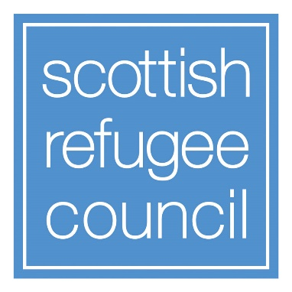

Participants Information Pack
New Scots Engagement Events,
November 2023

INTRODUCTION

This information pack will provide you with information on the New Scots Integration Strategy which will help you understand what is has achieved and how, with your input, we are looking to make it relevant to address the issues refugees face in their integration journey.

The links below cover the last iteration of the Strategy and a summary of the key findings of its evaluation report, whilst this paper presents an abridged draft of the latest New Scots Integration Strategy. The draft strategy document has been developed by the New Scots partners: The Scottish Government, COSLA, representing Scotland’s local authorities and Scottish Refugee Council. Over the last two years consultation and engagement has already been undertaken with a variety of stakeholders to inform the new strategy in different ways. These are:
- various research projects including a large research study by Glasgow University,
- an independent evaluation of the New Scots Strategy delivery and learning from funded refugee integration projects,
- learning events between unfunded and unfunded organisations on particular refugee integration themes,
- a New Scots conference in November 2022.

Links to recommended reading:

Please click on the following links to be taken to some documents we recommend you try and familiarise yourself in advance of the engagement event.

The New Scots Refugee Integration Strategy 2018–2022

The Evaluation of the New Scots Refugee Integration Strategy 2018–2022: Key Findings Summary

New Scots Refugee Integration Strategy
(Draft & Abridged)

Vision and purpose
The New Scots vision is for a welcoming Scotland where refugees and asylum seekers are able to rebuild their lives from the day they arrive.

The purpose of the New Scots strategy is to coordinate the efforts of organisations and community groups across Scotland involved in supporting forced migrants. It provides a clear framework and governance structure for all those working towards refugee integration and aims to support an effective implementation of the rights and entitlements of New Scots. It assists the work of all partners to make the best use of resources and expertise that are available across Scotland. It does this by respecting and reflecting Scotland’s geographic complexity and by promoting partnership approaches, joined–up working and early, inclusive and evidence–based intervention as part of a place–based approach.
This strategy envisions local communities becoming more able to adapt as a result of their welcoming of New Scots and the sharing of culture and skills. In order to support a long–term approach, this Strategy is not time limited. We will publish a Delivery Plan, which will be developed with partners and stakeholders and refreshed regularly, showing the specific actions we will take, and when they will be undertaken.
The New Scots Refugee Integration Strategy aims to support refugees and people seeking asylum in Scotland’s communities. The New Scots Strategy is the result of a long–standing partnership between the Scottish Government, the Convention of Scottish Local Authorities (COSLA) and the Scottish Refugee Council. The strategy both supports – and is supported through – the many partnerships and initiatives that exist across Scotland to welcome refugees.
From its inception, the New Scots Strategy has acknowledged integration is different from assimilation; that integration is not just about new arrivals learning the rules of their host society, places of dwelling and communities. Instead, integration takes place through equitable interactions between people from diverse cultures through dialogue and respect. Every refugee brings with them languages, global connections, music, games, stories, and many other intangible resources that they contribute as they set up new homes in Scotland. Supporting integration takes place at many levels. It requires partnership working among employers, schools, doctors, and many others, and also specialist support from local authorities such as community development workers and housing. Some refugees are qualified professionals such as doctors or engineers, who need support having their credentials validated; for some, Scotland is the first place where they have the chance to learn to read and write. All refugees, however, have a history of loss, with many experiencing violence, oppression, and suffering. Instances of gender–based violence and violence against refugees who identify as LGBTQ are also common; with such instances occurring both in people’s country of origin and in their journeys seeking sanctuary. Supporting integration, therefore, has to begin with an awareness of trauma and conflict, and be rooted in a respectful, restorative, human–rights based approach to creating healthy and diverse communities.
Many international bodies uphold the New Scots Strategy as an example of best practice worldwide, with the UNHCR commending the strategy’s ‘long–standing dedication and serious intention to create a welcoming nation for those forcibly displaced’.
The partnership and the organisations engaging directly with refugees and people seeking asylum have successfully delivered numerous projects and supported refugees and people seeking asylum across Scotland since the inception of the second New Scots Strategy. Despite these achievements, however, those seeking to enact the New Scots Strategy have experienced numerous challenges which have had a significantly detrimental impact on their ability to effectively meet all of its aims.

Who are New Scots?
The UK is a signatory to the 1951 UN Convention relating to the Status of Refugees (Refugee Convention) and the supporting 1967 Protocol. The 1951 Convention is the key legal document defining who a refugee is, establishing the rights of refugees and setting out the responsibilities of signatory states. Article 1(A) of the 1951 Convention defines a refugee as a person who:
“Owing to well–founded fear of being persecuted for reasons of race, religion, nationality, membership of a particular social group or political opinion, is outside the country of his nationality and is unable or, owing to such fear, is unwilling to avail himself of the protection of that country; or who, not having a nationality and being outside the country of his former habitual residence as a result of such events, is unable or, owing to such fear, is unwilling to return to it.”
According to international law, everyone who satisfies this definition is a refugee. The 1951 Convention does not prescribe a specific mechanism through which states should determine refugee status. The recognition of refugee status is declaratory, not constitutive. This means that a person does not become a refugee because they are recognised; rather, they are recognised because they are a refugee.
Scotland, through this New Scots Refugee Integration Strategy, uses the term ‘New Scots’ to include people living in Scotland who have been forcibly displaced or are making a claim that they have a well–founded fear of persecution. The term ‘New Scots’ includes people who have been granted refugee status or another form of humanitarian protection, and their dependents; people seeking asylum and people seeking protection as a result of displacement, exploitation or political persecution; as well as those whose application for asylum has been refused, but who remain in Scotland.
While neither international law nor this strategy distinguish between refugees and people seeking asylum, there is a distinction in UK immigration legislation, which means they have different rights and entitlements under UK law.
Approach and Principles
The approach of the New Scots Strategy builds on the framework set out in the two previous strategies, drawing from the learning and experience that has been gathered during that time. Since 2014, Scotland has welcomed a significant number of New Scots. Learning from resettlement, asylum dispersal and responses to emergency situations have demonstrated the need for an agreed set of principles. This experience, alongside the findings from the research projects undertaken as part of the New Scots Refugee Integration Delivery Project, has helped to shape a refreshed Strategy that builds on existing good practice, rethinks and reshapes the areas that have shown to need improvement and presents innovative approaches to reach our collective goals of supporting New Scots.
There are six principles which form the New Scots approach:

Integration from day one of arrival
The key principle of the New Scots strategy is that New Scots should be supported to integrate into communities from the first day of arrival, and not just once leave to remain has been granted.
Integration is a long–term, multi–directional process which enables people to be included in and contribute to society and to their communities. For separated families and those arriving via resettlement programmes preparations begin before arrival. Evidence shows that if people are able to integrate early, particularly into education and work and with appropriate housing, they have better health and well-being outcomes as well as being more able to make positive contributions in communities and economically.

A rights–based approach
The New Scots strategy aims to empower people to know about their rights and to understand how to exercise them.
We support refugees and people seeking asylum because it is the right thing to do; people should be able to live safely and realise their human rights.
The strategy takes a holistic, human rights approach to integration that reflects both the formal international obligations the UK has and the long–standing commitment of successive Scottish Governments, and of local government in Scotland, to address the needs of New Scots on the basis of principles of decency, humanity and fairness.

Restorative and trauma–informed
Successful refugee integration involves approaches that are restorative and trauma–informed.
‘Restorative’ is a term used to describe practices and approaches which help to repair harm, build and maintain positive relationships, and resolve difficulties.
Research consistently shows that New Scots experience repeated trauma at many stages of their journeys. Integration approaches and practices should be trauma–informed, and services involving New Scots should be trauma–responsive. This means that services recognise the prevalence of trauma and respond in ways that reduce the impact of trauma on accessing services and that support recovery.

Involvement of people with lived experience of forced displacement
People with lived experience should be directly involved in decision making processes regarding refugee integration. There is strong evidence that when this happens, outcomes for people involved are improved.
The New Scots strategy, aims to encourage engagement with and participation by New Scots and refugee–led organisations. Refugees and people seeking asylum engage directly with a range of services and activities run by New Scots partners, helping to build the knowledge and experience that partners bring to the strategy.
New Scots partners and New Scots themselves have actively worked to grow participation, agency and leadership amongst refugee groups. Opportunities for participation will continue throughout the implementation of the strategy with a view to sharing good practice. This will support learning from different experiences of resettlement and dispersal across Scotland.

Inclusive, intercultural communities
Integration is an intercultural process: it involves dialogue and mutual learning between the many different cultures which make up our society. This can be achieved by ensuring language and cultural learning are well supported, both of home languages and of languages in their new communities. The New Scots Strategy also recognises that successful integration practices foster and depend on inclusive communities: this means that everyone within the community is included in processes of integration.
The New Scots Strategy embraces the principle whereby all communities across Scotland are enriched by practices which support positive intercultural interactions within inclusive communities, where people share and learn from each other’s different cultures and nobody is left out. This principle cannot be upheld without a commitment to supporting all people within communities where New Scots live.

Partnership and collaboration
The New Scots Refugee Integration Strategy has been developed collaboratively to coordinate the efforts of government, local authorities and the third sector across Scotland involved in supporting refugees and people seeking asylum.
The strategy has been built on a model of partnership working, led by the Scottish Government, COSLA and the Scottish Refugee Council. It is founded on the principle that all the partners work together as equals, collaborating within the devolved powers of the Scottish Parliament, towards a vision of a welcoming, just, and diverse nation.
The strategy draws on the support and expertise of many partners across public services, national and local government, the third sector, the private sector and community groups who are all working together to achieve collective goals. It is also informed by international standards of research and evidence. The New Scots Refugee Integration Strategy seeks to acknowledge and draw on the rich knowledge resources of individuals and communities engaged in integration.

Outcomes
New Scots partners have established six overarching outcomes, which this strategy will work to achieve.
- New Scots live in safe, welcoming communities, where everyone’s human dignity is respected and everyone is able to build diverse relationships and healthy intercultural bonds.

- New Scots are able to access well–coordinated services, which recognise and meet their rights and needs.

- New Scots understand their rights, responsibilities and entitlements in Scotland. New Scots are able to exercise these to pursue full and independent lives.

- Everyone living in Scotland understands integration inter-culturally and respects the diversity New Scots bring. New Scots pursue their ambitions through education, employment, culture and leisure activities in diverse communities.

- Policy, strategic planning, and legislation, that have an impact on New Scots, are shaped through their participation and informed by their rights, needs and aspirations.

- The principles of the New Scots Refugee Integration Strategy guide all future responses to crises that bring forced migrants to Scotland and seek to ensure all such migrants will be treated equally.

The outcomes that the strategy seeks to deliver are grounded in an approach that places refugees and asylum seekers at the heart of the communities in which they reside. As such, it recognises that, for approaches to integration to succeed, they must be about working in and with local communities, as well as with refugees and asylum seekers.
The New Scots outcomes will be progressed through actions and these will be set out in the Delivery Plan, which is to be developed with partners and stakeholders.

Defining and Understanding Refugee Integration

Defining refugee integration
- Integration is a multidirectional process. This means that expectations of making integration work are not only on New Scots or the communities where New Scots live. Institutions such as schools, healthcare providers and all levels of government must also be actively involved in ongoing dialogue and collaboration. Successful approaches to integration are about working with New Scots, the communities where they live, and all other elements of society involved in fostering integration. Such approaches must involve understanding the unique challenges and barriers that New Scots face, as well as willingness to regularly reflect on practices and, where necessary, adapt approaches to match changing needs.
- Integration is a multilingual process. This means that the many languages spoken by New Scots are welcomed and included as part of processes of integration. Successful integration includes practices to support multi–directional sharing of culture and language in communities across Scotland as New Scots resettle there.
- Integration is an intercultural process. This means that integration involves dialogue and mutual learning between the many different cultures which make up our society. Integration involves the active interaction between people from diverse cultures, where people share and learn from each other.
- Integration is a restorative process. This means that integration seeks to restore the rights and dignity of people who have been forced to flee their country. Integration requires an acknowledgement of the trauma that New Scots have experienced (as part of their well–founded fear of persecution and their journeys to seek sanctuary) and trauma–informed practices to support people in rebuilding their lives.
- Integration is an inclusive process: this means that everyone within the community is included in processes of integration. Integration practices must also recognise and foster the existing skills and knowledge of New Scots and people from receiving communities so that everyone can participate in flourishing Scottish communities.

New Scots Refugee Integration: understanding integration
The model of integration developed by Ager and Strang (2008) has informed Scotland’s New Scots Refugee Integration Strategy for over a decade. Human rights are considered to be the foundation of the model, while language and cultural knowledge, safety and stability are seen as key facilitators of integration. Social connections are understood as being essential in order to access services and feel settled into local communities. Meanwhile, the means of achieving integration – such as employment, housing, education and health – can also be understood as markers of whether or not integration is being achieved.
Drawing on learnings from the Covid–19 pandemic and the large-scale relocation and resettlement of people from Syria, Afghanistan and Ukraine, the New Scots Strategy needs to adopt an expanded understanding of integration – as depicted in the diagram below (Fig. X). This model develops the concept of integration as a multifaceted, growing and evolving process, and is presented through the image of a tree: a growing, dynamic entity.
Using the image of the tree, we can see that the Ager and Strang model is like the trunk and branches: the more visible aspects and indicators that determine integration. This re–framing develops the roots: those principles, processes and practices which sustain and support the whole tree by showing 'how' the processes of refugee integration can happen without becoming assimilation.
As the diagram below illustrates, the principle of restorative integration is the tap–root on which the whole dynamic process depends. If integration practices do not seek to restore the rights and dignity of people who have been forced to flee their country and seek sanctuary, they do not sufficiently support New Scots to resettle in their new communities.
Approaches which place migration justice and accountability at the centre of integration practices support the visible parts of the tree – these approaches are reflected in the New Scots strategy (see Approach and Principles section above).
The whole process of integration needs to be trauma–informed, inclusive, intercultural and multidirectional if it is to be sustainable. This process is explained in ‘defining refugee integration’ above, and represented by a lower level of roots in the diagram below.
The deepest roots represent those practices through which integration takes place in our communities. These practices need to be multilingual; supportive of intercultural dialogue, conflict transformation and peace building. They must also be informed by the principles of community development and learning.

Model illustrating an expanded understanding of integration

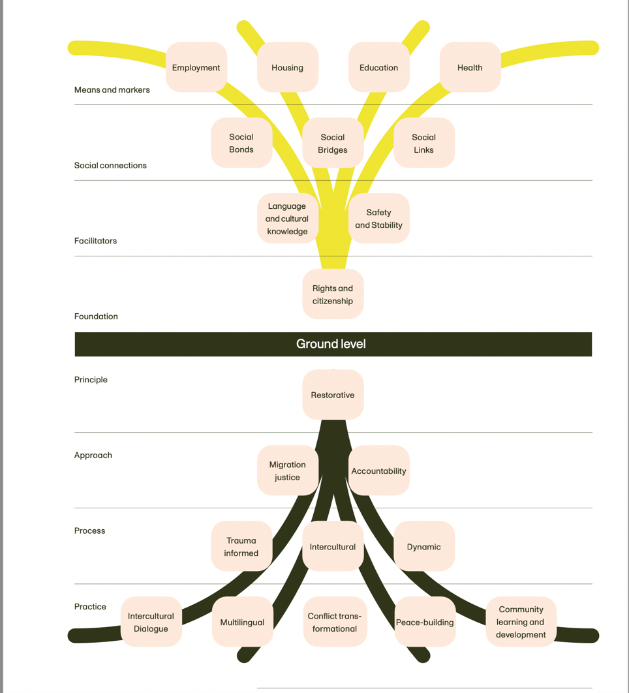

This project is part funded by the EU Asylum, Migration and Integration Fund. Making management of migration flows more efficient across the European Union.

The Scottish Parliament is a devolved legislative assembly, with the Scottish Government as its administration, whose powers are both limited by, and subject to change by, the United Kingdom Government. COSLA acts on behalf of the 32 locally elected councils and their governments across Scotland, each of which has its own party political makeup and distinct relationship to the Scottish Government, the UK Government, and other Scottish councils. The Scottish Refugee Council is an independent charity led by and for refugees living in Scotland that works with the Scottish Government, COSLA and other partners to uphold the human rights of refugees within Scotland but also reserves the right to speak out on behalf of refugees.
See p. 6 for more detail and explanation.
Lawrence Bottinick, Senior Legal Officer, UNHCR London, in Phipps, Aldegheri and Fisher (2022) p. 111
The achievements and challenges experienced since the inception of the second New Scots strategy are detailed in annex
We are aware of the complexity surrounding this terminology and welcome input from the NS core group
Further contextual information about the arrivals to date as of publication can be found in the annex
While the second New Scots Strategy stated as a key principle the importance of ‘Integration from Day 1”; conversations with people who are New Scots indicated that the phrase “Integration from Day 1” is felt to erase prior experience and history. ‘Integration from day of arrival’ honours the provenance and journeys and experience of New Scots. This language also encourages the understanding of integration as a multidirectional process wherein all actors, including New Scots, bring skills and stories.
For examples of what integration looks like in practice / on the ground, see research reports such as The New Scots Refugee Integration Strategy: A report on the local and international dimensions of integrating refugees in Scotland (Phipps, Adegheri and Fisher 2022) available at: https://www.gla.ac.uk/media/Media_900243_smxx.pdf
Source: The New Scots Refugee Integration Strategy: A report on the local and international dimensions of integrating refugees in Scotland. (Phipps, Aldegheri and Fisher (2022) p. 109) available at: https://newscots.scot/wp–content/uploads/2023/06/The–New–Scots–Refugee–Integration–Strategy–A–report–on–the–local–and–international–dimensions–of–integrating–refugees–in–Scotland.–.pdf

